The Open Source Audit
________________________________
A Capstone Project for OSS NGMC Course

Course: Open Source Software | Unit Coverage: 1 – 5 Max Marks: 100

Student Name | Registration number
Arnav Sharma | 24BCE11325
Slot | Date of submission
B22+B24 | 29/03/2026

INTRODUCTION
_______________________________________________________________

This audit is an audit of Git, a free and open source version control system and the main goal is not just to understand what git actually does but why it exists, who built this,what its license means, and how it has shaped the software world

Git was chosen because it is one of the most widely used open source tools in existence

Now most of the software that powers the modern world was not built by one company for profit but was built openly, shared freely, and improved by communities of developers, now Git is a perfect example of this - it was created out of frustration with proprietary software and released freely so it could never be locked away again

Now this report is divided into 4 main parts:-

- Part A talks about how Git was created, what problem it solved, what its GPL v2 license actually means and whether open source software is ethical
- Part B looks at how Git is installed on a Linux system where its files live, what permissions it has, and how it is managed
- Part C maps the ecosystem around Git what tools depend on it, what it has inspired like GitHub and GitLab, and who maintains it
- Part D compares Git directly against proprietary alternatives like
Microsoft's Team Foundation Server, looking at cost, security, support, and freedom

Now i would just like to phrase a line from a random man who said this about git "I'm an egotistical bastard, and I name all my projects after myself. First Linux, now Git."
And he was none other than Linus Torvalds himself.

Part A — Origin and Philosophy

A1. The problem this software was created to solve

Before Git, developers used tools like CVS and SVN to manage code, but there were some problems like, These tools were centralized meaning all code lived on one server and if that server went down, nobody could work and they were also slow, couldn't handle large projects well, and had no good way to handle thousands of contributors working simultaneously now The Linux kernel project — one of the biggest and most complex software projects in the world — was struggling with these limitations.

Now in order to solve this problem in 2002, Linus Torvalds started using a proprietary tool called BitKeeper to manage his Linux kernel code, now BitKeeper was owned by a company called BitMover, they allowed the Linux team to use it for free as they were going for a better cause but In 2005, a Linux developer named “Andrew Tridgell” tried to reverse-engineer BitKeeper's protocol and because of that bitmover was furious and revoked the free license immediately, now suddenly the entire Linux kernel development team had no version control tool and this exact moment changed everything.

Linus Torvalds was so frustrated that he decided to build his own tool from scratch now he had very specific requirements, it had to be fast, distributed, and free, here distributed means every developer has a full copy of the entire code history on their own machine, no central server needed and in just 10 days on april 2005, linus wrote the first version of git. He immediately released it under the GPL v2 license, specifically so no company could ever lock it away like BitKeeper did and byb june 2005, the linux kernel itself shifted to git.

Git is proof that the best tools are not always built by the biggest companies, sometimes they are built by one person who was simply tired of being told what they could and could not do with their own software

A2. The license — what it actually says

Git is released under GPL v2, GNU General Public License version 2 and this license was written by Richard Stallman in 1991 and it became one of the most widely used open source licenses in the world. The full license text can be found in Git's source code repository under the file named COPYING, GPL v2 is a copyleft license meaning any modified version of Git must also be released under the same license.

Now there was a very great question that "What are the four freedoms and does Git's license grant all four?" and according to Richard Stallman those 4 freedoms are:-
Freedom 0 — The freedom to run the program for any purpose. Git grants this
— anyone can use Git for any project, personal or commercial
Freedom 1 — The freedom to study how the program works. Git grants this — the entire source code is publicly available
Freedom 2 — The freedom to redistribute copies. Git grants this — you can share Git with anyone
Freedom 3 — The freedom to improve the program and release improvements. Git grants this — but under GPL v2 you must share those improvements publicly

And yes git gpl v2 grants all four freedom

“Can a company modify Git and sell it without sharing changes?” And the answer is - NO, this exactly what GPL v2 prevents, GPL v2 has a condition called copyleft, if you modify Git and distribute your modified version, you must release your source code under the same GPL v2 license

“What is the difference between GPL and MIT licensing? Which would you choose for something you built, and why?”

GPL — strict copyleft. Anyone who modifies and distributes must share their code. Protects the community but restricts commercial use
MIT — very permissive. Anyone can do anything with the code including making it proprietary. Maximum freedom but no protection
Now according to me i would choose MIT as it is better if someone wants a small personal project or library and as a person i am i need maximum freedom which i can get from MIT.

“Is there a difference between 'free as in free beer' and 'free as in freedom'? Give an example from your chosen software.”

Now free as in beer means it costs zero money, like a free drink. But you have no rights over it whereas free as in freedom means you have rights as to use, study, modify, and share. Now Git is literally both as it costs nothing and gives u free freedom
Example: Windows is sometimes free to download (free beer) but you cannot read its source code or modify it (not free freedom), Git on the other hand gives you complete freedom — you can download the source code right now, modify it, and run your own version

A3. The ethics of open source

“Should all software be open source?”

Argument FOR:
Software is knowledge, and knowledge should be free, now open source software can be audited by anyone meaning security flaws can be found and fixed faster, It prevents monopolies — no single company can control a tool the whole world depends on.
Argument AGAINST:
Companies need to make money to survive if all software must be open, there is no business model and besides that there are many softwares that if they become open source it can be a national security threat and open source not always means better quality, it wholly depends on the community behind it.

Is it ethical for companies to profit from free community labor?

It is legal but not always ethical. Companies that build billion dollar products on free community work have a moral responsibility to contribute back — not just in code, but in funding the developers who maintain those projects

What does 'standing on the shoulders of giants' mean in the context of software? Does open source enable or undermine original innovation?

Open source overwhelmingly enables innovation. The fact that a student in a hostel room can build a startup using the same tools as Google — for free — is only possible because of open source. Git is a perfect example of this democratization of software development

Part B — Linux Footprint

Git is available in the default package repositories of all major Linux distributions, On Ubuntu/Debian based systems it is installed using:

On RHEL/Fedora/CentOS based systems:

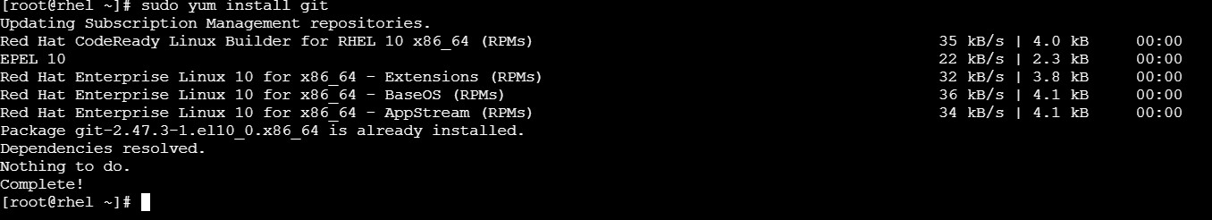

It can also be compiled from source by downloading the tarball from git-scm.com
Installing from package manager is recommended because it handles
dependencies automatically and integrates with the system's update mechanism

Now lets talk about the Key Directories of Git:-

- Git's binary lives at /usr/bin/git — this is where the executable program is stored
- System wide Git configuration is stored at /etc/gitconfig
- User specific configuration is stored at ~/.gitconfig (inside the user's home directory)
- Git repositories store their data inside a hidden .git folder within each project directory
- This .git folder contains everything — the full history, branches, commits, and configuration of that project

Now the concept that comes is user and groups, Git runs as the currently logged in user, it do not run as a separate system user or daemon and this is all intentional as Git is a developer tool, not a system service and this also matters for security because Git only has access to files that the current user has permission to access and it cannot accidentally read or modify system files it has no business touching.

Git itself is not a service, it does not run in the background like Apache or MySQL, it is a command line tool that runs only when you call it, however git daemon is lightweight service that can serve Git repositories over a network, It can be managed with systemd like this:

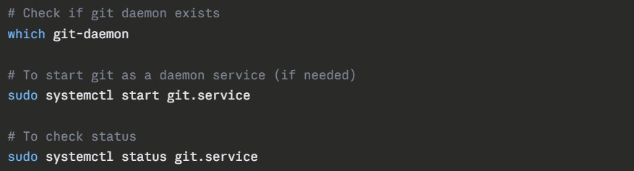

Because Git is installed through the system package manager, it receives updates through the same mechanism as all other system software and on ubuntu, running this command updates Git along with everything else:

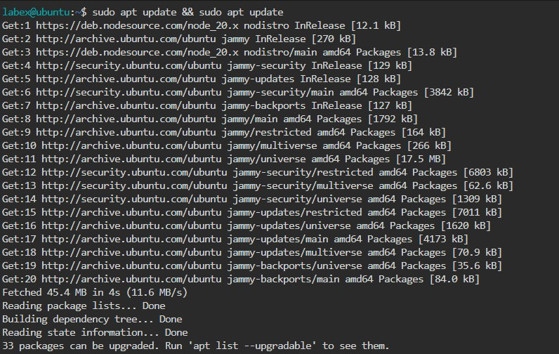

Security patches are pushed by the Git open source community, reviewed publicly on the git mailing list, then packaged by distribution maintainers like ubuntu and fedora and this also means the entire update pipeline is transparent anyone can read the patch, understand what it fixes, and verify it before it reaches their machine and this is fundamentally different from proprietary software where updates are pushed silently with no explanation.

Part C — The FOSS Ecosystem

What Git depends on

Git is written in C, so it depends on a C compiler called GCC (GNU Compiler Collection) which is itself open source and it uses the GNU C Library (glibc) for basic system functions and it also depends on OpenSSL or libssl for secure HTTPS connections when pushing and pulling code and besides that it uses libcurl for transferring data over the internet and also it uses zlib for compressing repository data to save space and every single one of these dependencies is open source, Git is built entirely on a foundation of free software.

This shows all the libraries Git depends on at runtime.

What Git has enabled and inspired

Git did not just solve a problem, it created an entirely new ecosystem worth hundreds of billions of dollars like:
- GitHub (2008) — the world's largest code hosting platform, built entirely on
Git. Acquired by Microsoft in 2018 for **7.5 billion dollars
- GitLab (2011) — an open source alternative to GitHub, also built on Git
- Bitbucket — another Git hosting platform owned by Atlassian
- Git LFS (Large File Storage) — an extension built on top of Git for handling large files
- CI/CD pipelines — tools like Jenkins, GitHub Actions, and GitLab CI are all triggered by Git commits

Forks and spin-offs

Because Git is open source under GPL v2, anyone can fork it and build their own version now there are some examples of this:
- Gitolite — a tool built on Git for managing access control to repositories
- Gerrit — a code review tool built on top of Git, used by Google and Android development
- JGit — a pure Java implementation of Git used inside Eclipse IDE
- libgit2 — a portable C library that implements Git which is used by GitHub's backend

All of this was possible because git’s source is open and free to build upon

Git's relation to the LAMP stack and web

LAMP stands for Linux, Apache, MySQL, PHP — the classic open source web server stack although Git is not part of the original LAMP stack but it is deeply connected to it, every LAMP stack application — the PHP code, the Apache config files, the database schemas — is managed and version controlled using Git and modern web development workflows called DevOps and CI/CD rely entirely on Git to automate testing and deployment, when a developer pushes code to GitHub, it can automatically trigger deployment to a web server running Apache on Linux — connecting Git directly to the LAMP ecosystem.

Community and Governance

Git is maintained by a core team of volunteer developers from around the world,
The project is coordinated through a public mailing list called git@vger.kernel.org
— all discussions, patches, and decisions happen publicly here and Junio C Hamano has been the primary maintainer of Git since 2005 — Linus handed him control just months after creating it There is no single company that owns or controls Git - Major conferences like Git Merge bring the community together annually and anyone can submit their patches and get reviewed publicly

Part D — Open Source vs Proprietary

Dimension | Git(open source) | Microsoft TFS / Azure DevOps (Proprietary)
Cost | Completely free forever | Paid licensing — starts at $6 per user per month
Security | Anyone can audit the source code and find vulnerabilities | Source code is closed — you must trust Microsoft to find and fix bugs
Support | Community forums,  Stack Overflow, official documentation at git-scm.com | Official Microsoft support  with guaranteed response times
Reliability | Used by millions of projects worldwide  including Linux kernel  itself | Enterprise grade with Microsoft's infrastructure backing it
Free to modify | Full freedom — you can  fork Git and modify it however you want | Zero freedom — you cannot modify or inspect the source code
Community vs corporate control | Controlled by volunteer community, no single company owns it | Fully controlled by Microsoft — they decide all features and pricing
Your overall verdict | Write your own honest opinion here | Write your own honest opinion here

Expand on Cost

Git is completely free, there is no licensing fee, no per user charge, no enterprise tier and Microsoft TFS and Azure DevOps charge per user per month, also for a startup or individual developer this difference is enormous, However the cost of proprietary tools sometimes includes support, training, and integration which Git does not provide out of the box Companies often end up paying for GitHub or GitLab anyway but those costs are for the hosting platform, not for Git itself.

Expand on Security

Git's source code is completely open, any security researcher in the world can read it, find bugs, and report or fix them. This is called "many eyes make all bugs shallow", a concept from Eric S Raymond's famous essay "The Cathedral and the Bazaar", With Microsoft TFS you must trust that Microsoft's internal security team has found and fixed all vulnerabilities, you have no way to verify this yourself, in practice Git has had very few serious security vulnerabilities in its 20 year history, when vulnerabilities are found they are fixed publicly and transparently.

Expand on Support and Reliability

This is where proprietary software has a genuine advantage, microsoft TFS comes with official support, you can call Microsoft and get help also git's support is community based; Stack Overflow, mailing lists, documentation. For large enterprises this matters, they need guaranteed response times and someone to hold accountable. However Git's reliability track record is extraordinary, it manages the Linux kernel which has thousands of contributors and decades of history. No version control system has ever been tested at that scale.

Conclusion:

“Question 1 — Would you recommend Git for real world deployment?”
Yes, without hesitation for almost any use case and Git is already the industry standard, not recommending it would be going against the entire software industry and the only scenario where a proprietary alternative makes sense is in a large enterprise that needs guaranteed official support and deep integration with Microsoft products like Visual Studio and Azure and For startups, individual developers, open source projects, and most companies Git is the obvious choice.
“Question 2 — Would you contribute to Git?”
Absolutely yes, contributing to Git means your work improves a tool used by every developer on Earth and even small contributions like fixing documentation or reporting bugs are valuable also git's contribution process is open — anyone can submit a patch to the mailing list.

CONCLUSION
________________________________________________________________

Before this project, Git was just a tool — something you use without thinking about, after researching its origin, it becomes clear that Git exists because of a very specific moment of frustration with proprietary software and Linus Torvalds could have kept Git private or sold it — instead he released it under GPL v2 so it could never be taken away from developers, that single decision changed the entire software industry.

Open source is not just a licensing model — it is a philosophy about how knowledge should be shared
The fact that Git is free, transparent, and community controlled means no single company can hold developers hostage
Every tool you will use in your career — the editor, the compiler, the server — sits on open source foundations
Understanding why those foundations exist is as important as knowing how to use them

This project changed the way I look at the tools I use every day. I never thought about why Git was free or who maintains it, now I understand that it exists because someone refused to accept proprietary control. As a developer, I want to be someone who gives back to that ecosystem, not just someone who takes from it.

